Aeolus AVIONICS ROUND-2
Task 1
I would choose this sensor architecture because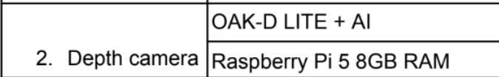
Because OAK-D Lite has two mono cameras and one rgb camera setup and a myriad X VPU chip. It can compute the depth inside the camera itself. The compute here is weak as it’s a raspberry Pi 8GB RAM,it doesn’t matter because most of the work hgere is done by the camera. The Pi just receives the the final depth data and handles the flying logics. The Ai is also more helpful in this use case scenario as it run a neural network to search for Odysseus while also handling the depth and scanning the ground . there is no gpu available in this setup but it is not much of a disadvantage because it not needed in this scenario. moreover its light weight fits the tight weight limit of 2.5 kg.
The weightage of parameters are :

Weight>Power>Compute>Use case>Cost

Weight :
This is the highest priority as we are trying to build a 2.5 wight drone on a 10” frame which is pretty difficult so every gram matters for the flight time. Considering this a rescue mission we obviously need a longer flight time.
Power :
Power also has the same reason as weight the lower power consuming components the longer the flight time . But we cannot also compromise performance for the power rating.
Compute :
This is an important part we need a powerful computing chip too weak is also bad and too powerful is also bad. But the priority of this parameter highly depends on the use case of the drone.
Use case :
This parameter is not so important because most of the task can be done by a generalized drone. But in case of niche problems this becomes an important parameter.
Cost :
Considering this a rescue mission the cost doesn’t matter here. But Cost also plays a major role while building a drone irl
The priority I have given to the parameters here are based on the problem statement given. The priority obviously will change depending on this problem statement.

Bonus:
I would tilt the OAK-D Lite down about 20 – 30 degrees from the horizontal, so the camera looks a little down rather than pointing staright, this is helpful because this is a search mission and when we tilt the camera, it can scan for obstacles as well as odysseus at the same time.
Alternate Build:
Keeping the same setup, we can just change the camera to a wide-angle alternative like OAK-D Pro W, this helps to scan and clear a larger area in a single flight with a limited flight time.

Task 2:
RC Transmitter and receiver:
It is used for manual pilot control and flight mode switching.The best model which can be chosed is RP1 ELRS 2.4GHZ because the digital serial emilates the PWM/PPM timing mismatch.
The signal line is connected to the RC IN pin.It is powered by 5V directly from the Pixhawk RC IN rail.
It communicates over CRSF protocol and has a range of 10-30+ km range.
Telemetry Module
Use:2-way MAVLink link to Ground Control Station for live status,waypointsand parameter tuning.
Model which can be used is Holybro SiK Telemetry Radio V3 (915MHz/433MHz).
It connects to pihawk TELEM1 or TELEM2 via JST-GH connector.
Powered by 5V rail supplied via Pixhawk TELEM port.
Protocol:MAVLink over transpaert serial
Range:1-2 km to 10+
Video Transmitter(VTX)
Its used for Real-time visual feedback for pilot viewing or FPV navigation.
A Rush Tank Solo 5.8GHz 1W Analog VTX or DJI O3 Air Unit for Digital HD.
Connection: Camera video input to VTX video pin SmartAudio control wire to a free Pixhawk UART TX pin for OSD configuration.
Its is powered by 7V-36V BEC output from a power module.
Operates by a SmartAudio/Tramp protocol with 5.8GHz analog RF video output. Has a 2-10km

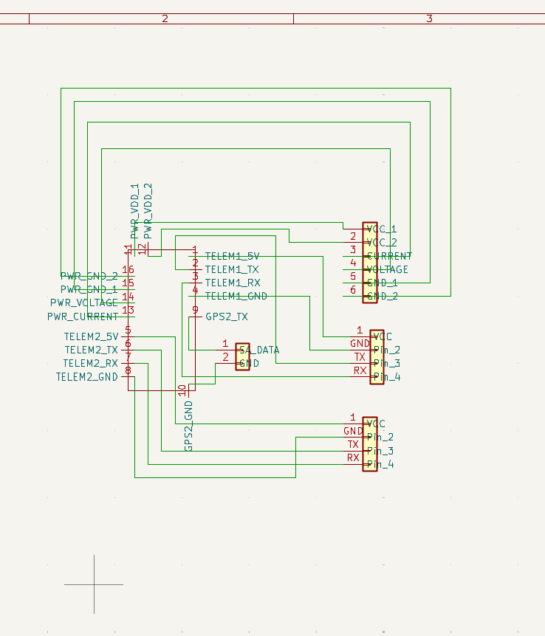
p.s (Pls don’t mind this beautiful wiring)

Task 3
I would choose a 4S 10k mAh LiPo battery and for the ESC I’ll choose a 30A ESC
Reasons for my choice:
A 4S bettery has a volage of 14.8V which is much more efficient than a 3S battery . A 10k mAh can last for almost 16 min and has a weight of 940 grams which leaves a 320g free from the weight limit.
In the case of ESC , I chose a 30A ESC rather than the standard 20A because the mototrs pull about 16.4A max but this is too close to 20 A so a 30A ESC will be much better and there is no much weight difference between both.
Weight calculation:
Frame 782 g
4 motors 252 g
4 props 52 g
ESC 25 g
Flight ctrl 50 g
GPS 25 g
Wires/misc 55 g
Total 1,241 g
So, for battery 2500-1241=1259g is left
Working of motor:
2500/4=625g of thrust per motor
From the motors data we can see for a thrust of 625g the motor works at 60% throttle where each takes about 5.6A and 90W.
Total Power:
90*4=360W (only for motors)
Adding a 20% power for the real world conditions like air resistance and other losses.
i.e 360*120/100=432
taking power for other electronics too we can say we need approximately 440W in total.
Energy:
440W * (12/60)h=88Wh
Considering a safe reserve of 20% in the battery . 88Wh must be only 80% of the total capacity.
The minimum required energy will be :
88/0.8=110Wh
Capacity:
Capacity=energy/Voltage=110/14.8=7.4Ah=7400mAh
Now checking the required conditions by choosing a battery:
Considering a 4S(14.8V)10,000mAh battery,
It weighs around 940g, we had a margin of 1241g for the battery so it satisfies that condition
In case of energy it has a energy of 148Wh,with usable energy(80% of total) of 118Wh so the flight time will be 118/440 = 0.266h of flight which is almost 16min of flight time which is easily higher than 12 min.
In case of ESC the worst case current drawn at 100% throttle is 16.4A.
But choosing a ESC of 30A will give a safe headroom of 1.8x which is far more than necessary lol.
Bonus:
The chosen motor is actually the best in this case. But for a 5-15% better efficiency we need to switch to a bigger motor (28mm stator motors)which weighs around around 30g heavier per motor so a 120g gain in total weight. This is acceptable in the current build but if we wanna add some cameras or other things to the drone removing the 120g from the remaining 320g will make it hard to add parts later. Examples of bigger and alternative motors include iFlight XING2 2814, T-Motor MN22-series .

